The Way of Downloading 3 Free ITU Recommendations

- Go to ‘Electronic Bookshop’ of ITU
http://www.itu.int/publications/template.aspx?lang=e&menu=main&media=download&target=/publications/EBookshop.html

Click on ‘3 Free Recs’

- Select ‘I wish to REGISTER in order to download up to three (3) Recommendations free of charge’, then click ‘Continue’.

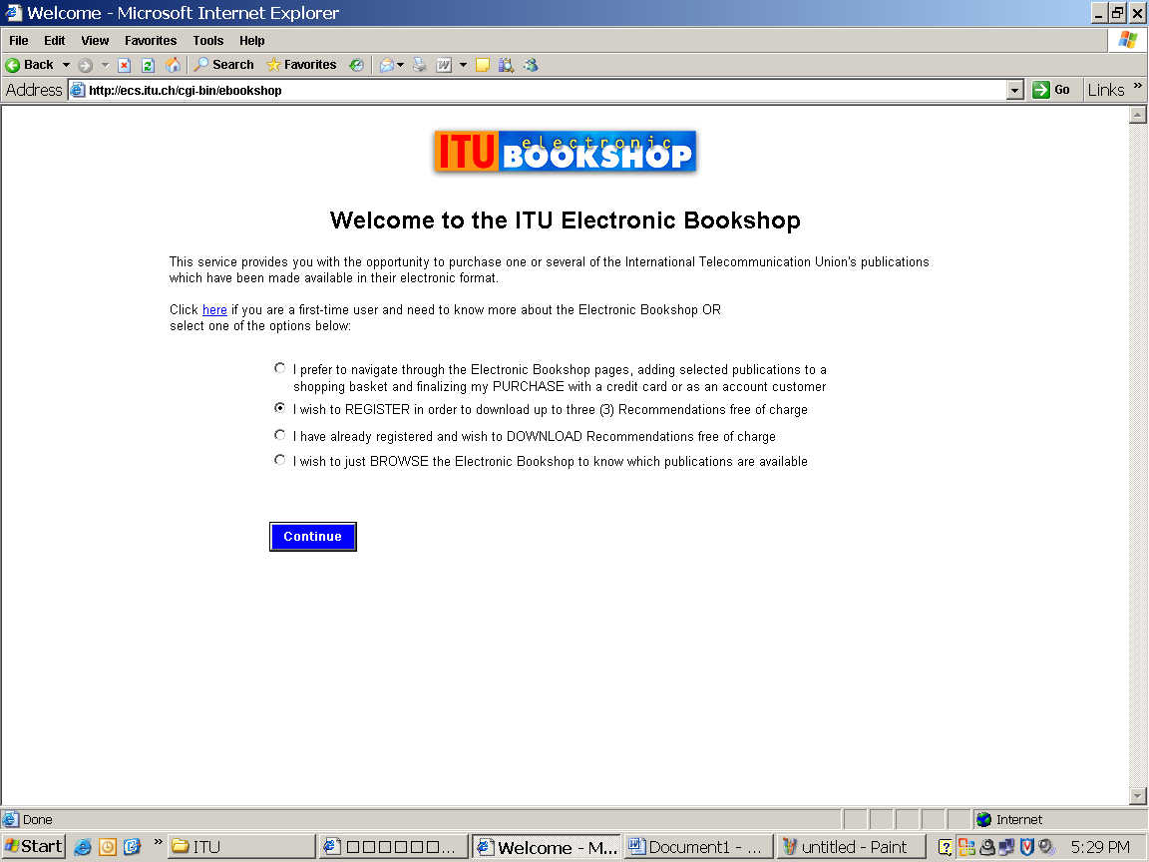

- Fill up the registration form, then submit it.

- Click ‘Confirm application’
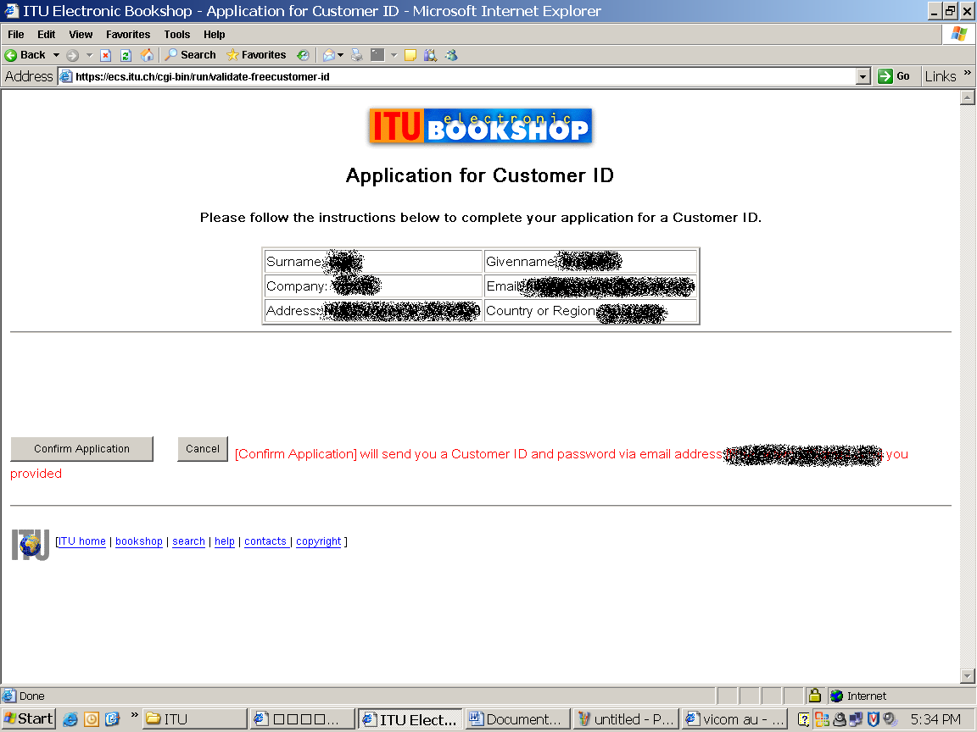

- Just wait and you will receive an email including login name and password for 3 free downloading. It may come like this:

Customer ID: aaaa@aaaa.com
Password: xGaFfWwO
Expiry date: 31 December 2006

- Obviously, if you have more than one email for registration, then…

Enjoy!

